PERTH MODERN SCHOOL


UNIT 3C/3D MAS – 2011

TEST 1 – POLAR COORDINATES & COMPLEX NUMBERS

NAME: _________________________________________ DATE: _______________

[To achieve full marks and to allow assessment of particular outcomes, working and reasoning should be shown.]
[A maximum of 2 marks will be deducted for incorrect rounding, units, etc.]

This is Resource Rich – 50 minutes for 53 marks:

- [1, 1, 1, 1 = 4 marks]
Convert:
  - (4,-6) into polar coordinates with -180° < θ ≤ 180°.

  - (3,- 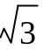) into exact polar coordinates with -π < θ ≤ π.

  - [4,35°] into Cartesian coordinates.

  - [8,-¾π] into exact Cartesian coordinates.

- [3, 3 = 6 marks]
Clearly show how you obtain your answers, find:
  - the distance between [20,-210°] and [ 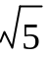,-50°].

  - the exact distance between 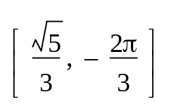and 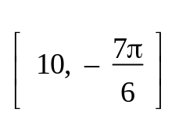.

- [8 marks]
Find the exact distance between ( 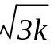, 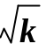) and 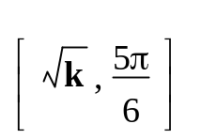. Draw a diagram.

- [3, 2 = 5 marks]
  - Find, in exact form, the modulus and principal argument of - + i, and hence rewrite - + i in exact polar (cis) form.

  - Convert 2 cis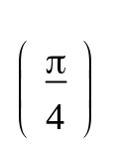into exact algebraic Cartesian/rectangular form.

- [3, 3 = 6 marks]
Evaluate, giving answers in exact form:
  - 4 cis × 2 cis 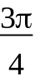

  - 4 cis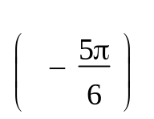
2 cis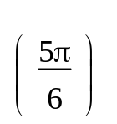

- [4 marks]
Given z = 2 cis , express z⁻¹ and in exact polar and rectangular form.

- [2, 2, 2, 2 = 8 marks]
The Argand diagram below shows the point representing the complex number z where | z | > 1. Plot on the same diagram, the points representing the complex numbers:
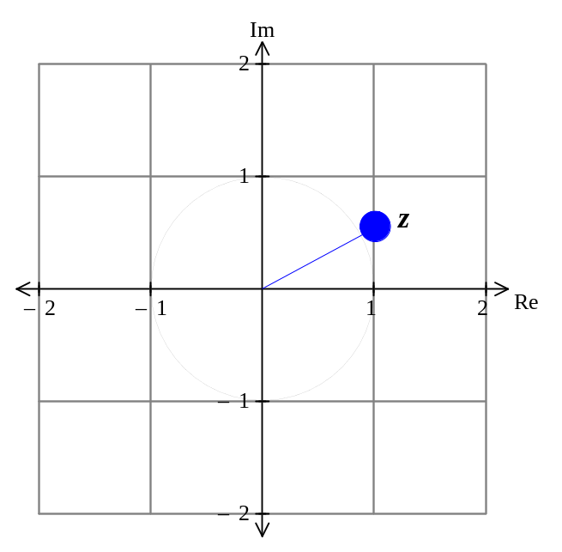a) b) iz c) z² d)

- [3, 3, 3, 3 = 12 marks]
Sketch on an Argand diagram, the locus of the point z = x + iy, satisfying each of the following conditions. In each case, give the Cartesian equation or inequality of the locus.
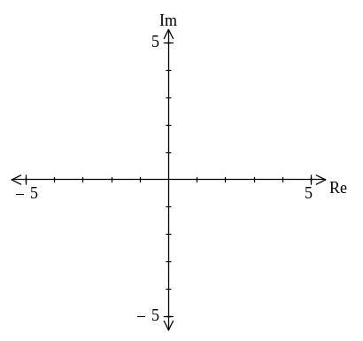a) Re(z) = -2 b) Im(z) = Re(z)

c) Re(z) + 2Im(z) > 3 d) Re(z).Im(z) = 1

